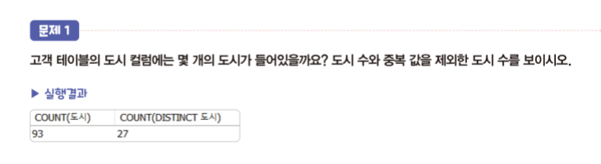



SELECT COUNT(도시), count(distinct 도시) FROM 고객;

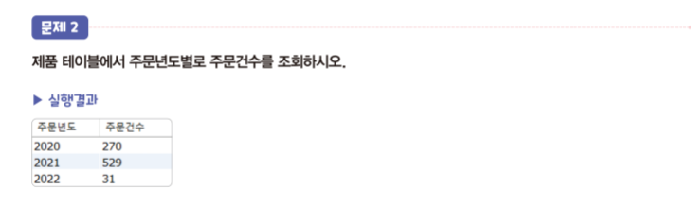



SELECT year(주문일) as 주문년도, count(year(주문일)) as 주문건수 FROM 주문 group by year(주문일) order by year(주문일);

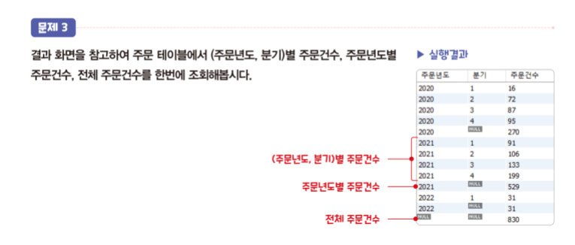

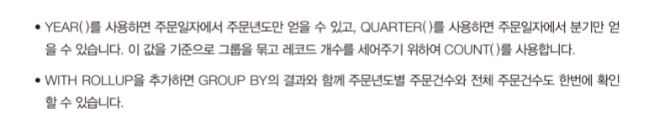

SELECT year(주문일) as 주문년도, quarter(주문일) as 분기, count(\*) as 주문건수

FROM 주문 group by year(주문일), quarter(주문일) with rollup;

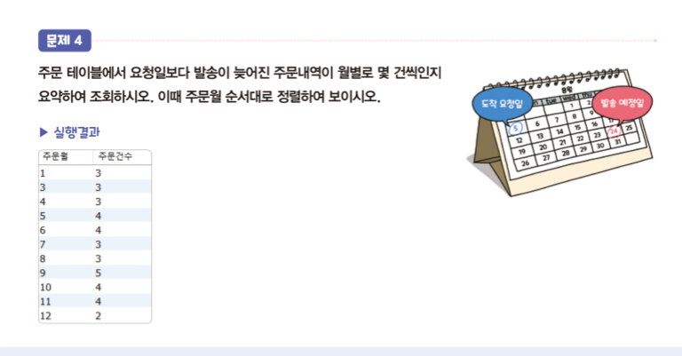

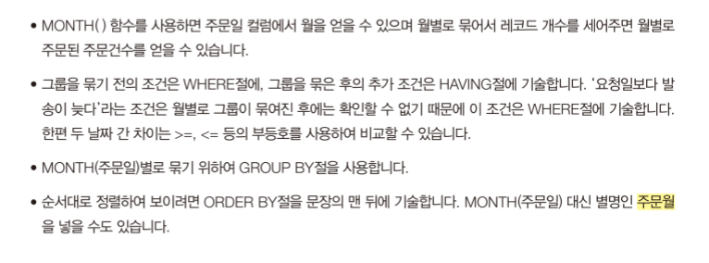

SELECT month(주문일) as 주문월, count(\*) from 주문 where datediff(발송일, 요청일)>0 group by month(주문일) order by month(주문일);

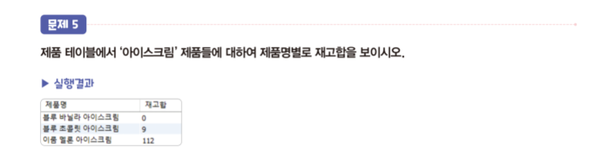

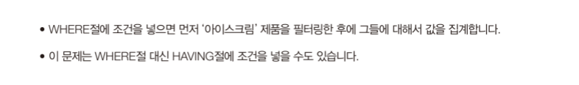



SELECT 제품명, sum(재고) as 재고합 FROM 제품 where 제품명 like '%아이스크림' group by 1;

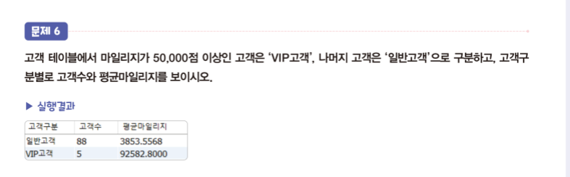

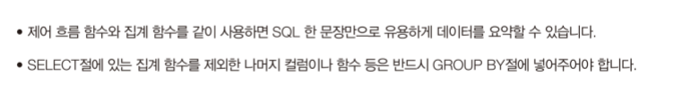

SELECT case when 마일리지>=50000 then 'vip고객' else '일반고객' end as 고객구분, count(\*), avg(마일리지) FROM 고객

group by (case when 마일리지>=50000 then 'vip고객' else '일반고객' end);